[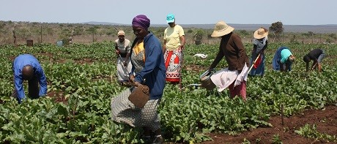](http://www.sz.undp.org/content/swaziland/en/home/ourwork/womenempowerment/successstories/women-empowered-to-produce-vegetables-commercially)